**SDA**

**Assignment #02**



**Instructor**

Zeeshan Ramzan

**Submitted by**

Abdul Haseeb Siddiqui

2021-SE-22

**Department of Computer Science,**

University of Engineering and Technology, Lahore, New-Campus.

15th February 2023

**Class diagram**

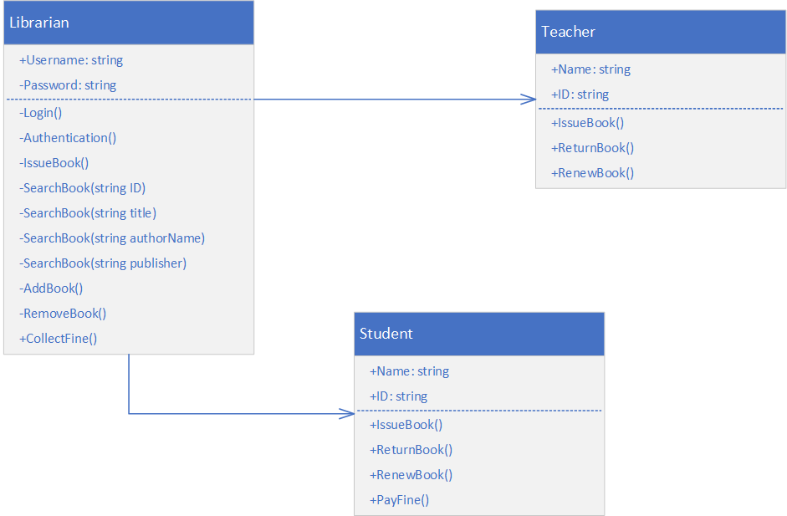

**Object diagram**

